HW1: Mid-term assignment report
Filipe Maia Antão [103470], v2023-04-03

1 Introduction 1
1.1 Overview of the work 1
1.2 Current limitations 1
2 Product specification 2
2.1 Functional scope and supported interactions 2
2.2 System architecture 2
2.3 API for developers 2
3 Quality assurance 2
3.1 Overall strategy for testing 2
3.2 Unit and integration testing 2
3.3 Functional testing 3
3.4 Code quality analysis 3
3.5 Continuous integration pipeline [optional] 3
4 References & resources 3

Introduction

Overview of the work
This report presents the midterm individual project required for TQS, covering both the software product features and the adopted quality assurance strategy.
The Application works as a tool to search and query the air quality of a given city.

Current limitations
The application works as expected to most cities(upon searching the city in the search bar, values of ozone, pm25 and pm10 for the day in question and next days). However, depending on the city and the station that provides the data, some values may be missing and this application does not deal with those missing values, returning an error page when it happens.

Product specification

Functional scope and supported interactions
This application can be used to query values of air quality of a given city, therefore that are a lot of use cases. A good one would be a person who’s going on vacation. He would search the city in the application and would get the values of air quality as well as a brief assessment of the danger.

System architecture
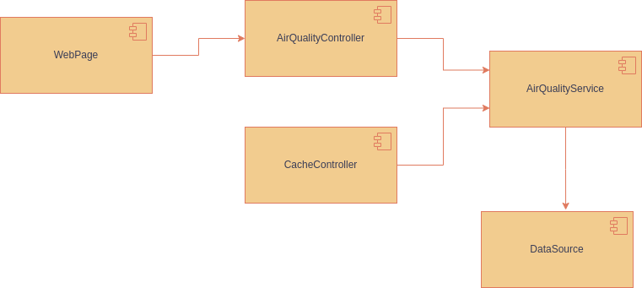
Technologies used:
- Spring Framework
- Thymeleaf
- External API for the retrieval of the air quality data (https://aqicn.org/api/)

API for developers
<what services/resources can a developer obtain from your project? document your API endpoints>
<note: for the homework, you are expected to expose two “groups” of endpoints:
- Problem domain: get the environmental data data by region/city, etc.
- Cache usage statistics: how many hits/misses,… >.

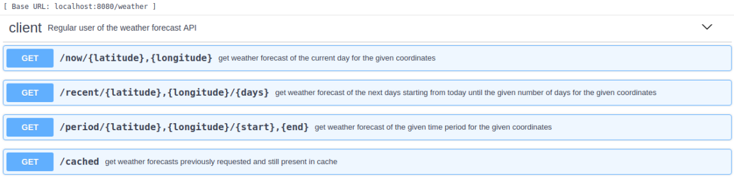

Quality assurance

Overall strategy for testing
[what was the overall test development strategy? E.g.: did you do TDD? Did you choose to use Cucumber and BDD? Did you mix different testing tools, like REST-Assured and Cucumber?...]

Unit and integration testing
Testing was done in all entities of our project(AirQuality, Cache, DataSource)
[may add some screenshots/code snippets for clarification]

Functional testing
[which user-facing test cases did you considered? How were they implemented?]
[may add some screenshots/code snippets]

Code quality analysis
[which tools/workflow did you use to for static code analysis? Show and interpret the results.]
[you may add some interesting lessons learned, e.g., some code smell reported by the tool that was difficult to spot and otherwise you wouldn’t address it]

Continuous integration pipeline [optional]
[did you implement a CI pipeline? What was the setup? Illustrate with screenshots, if applicable]

References & resources
Project resources
Resource: | URL/location:
Git repository | <link to your TQs repo>
Video demo | < short video demonstration of your solution; consider including in the Git repository>
QA dashboard (online) | [optional; if you have a quality dashboard available online (e.g.: sonarcloud), place the URL here]
CI/CD pipeline | [optional; if you have th CI pipeline definition in a server, place the URL here]
Deployment ready to use | [optional; if you have the solution deployed and running in a server, place the URL here]

Reference materials
<document the key components (e.g.: libraries, API) or key references (e.g.: blog post) that were helpful and certainly would help other students pursuing a similar work>

